Summary Rules
This summary is to remind you of the important issues during the competition.

What is Provided
Diskettes for back-ups, blank writing paper. Pens, pencils and erasers will not be provided. You may NOT take any aids of your own, such as program disks, calculators, manuals or books, into the competition room.

Directories and Execution Path
You will find the following directories on the hard drive of your computer:
C:\BOI98\TP for Turbo Pascal (Version 7.0)
C:\BOI98\BC for Borland C++ (Version 3.1)
All the packages are installed with help files.

Competition Tasks
Consult the overview sheet for the official task name, directory name, input and output files, the execution time limit that applies to every test run and the maximum points awarded for the task.
For each task you will get two descriptions: one in English and the other translated into your native language by your delegation leader. In case of any discrepancies between the two versions, the English version is authoritative.

Your Programs
You must create a subdirectory for your solutions on the floppy. The name of the subdirectory must be your code. At the end of competition you must copy all your solutions (both the source and compiled code) into this subdirectory. The filenames must correspond to the names of the problems in English. For example, if user with code EST_S9 writes his solutions in Pascal, he must place his soution to problem named Basketball into files
A:\EST_S9\BASKET.PAS
A:\EST_S9\BASKET.EXE
While you may choose to write your programs in any of the programming languages offered, to enable objective judging you must compile your programs as stand-alone MS-DOS executables. It is not necessary to write solutions to all problems in the same programming language.
No special features of the programming packages are needed, nor should they be used. In particular, the following features will NOT play a role in the programming tasks and are discouraged: Graphical output, mouse input, advanced file manipulation, advanced numeric processing and DOS calls.

External Communication
Your program may read and write files. You are not allowed to write to the ports or attempt to modify the system timer. Any attempt to do so will result in disqualification and a score of 0. Your program may only read the value of the clock counter.

Input Data
Programs should read their input data from ASCII text files and must not read from the keyboard.
You may assume that the input data agrees with the task description. You do not need to validate the input data.
Input data consists of a sequence of items. An item is either an integer or a non-empty character string of letters ("a" to "z" and "A" to "Z") and/or ("0" to "9"). Items are separated by either a single space character or a single end-of-line.
Examples of input files are provided for all tasks, both in the task description and the task directory, except for those tasks that do not use input files.

Output Data
Your programs are required to write their output data to the ASCII text file specified in the task description, except for tasks which are not required to write output files.
Programs are NOT required to write to the screen, and such output will NOT be evaluated. Remove all screen output from your programs before you create the final executable.
The output should be formatted exactly as shown in the task description. Never add output of your own, as this may disrupt the evaluation process.

Exit Code
Your program should terminate "normally" (i.e. with an exit code 0). In particular, C and C++ programmers should explicitly return 0 and NOT declare a void main.

Starting the Competition
Do not touch the keyboard or open the folder until the start signal is given.

Questions
During the first hour of the competition (09:00 to 10:00) you may submit written questions concerning any possible obscurities or ambiguities in the competition tasks. These questions will be answered by only one of the following:
"Yes", "No" or "No Comment".
You must submit your question(s) on the ‘Question Form’ provided, in English or your native language. If required, the question(s) will be translated into English by your delegation leader.
The Jury will answer every question submitted by the contestants. This may take some time, so you should continue working while waiting for the answer to your question(s). You will not be involved in discussion.
You may ask the lab supervisors for assistance at any time. The supervisors will NOT answer questions about the competition tasks, but will deliver your question forms, help you find toilets, and attend to computer problems.

Printing
No printing facilities will be available during the competition.
Backups
You will be provided with a diskette to backup your files during the competition. You are advised to maintain backups, so that you can recover in the unlikely event of a machine failure. If your machine fails with an irrecoverable error, you may be allowed a time compensation at the judges discretion.
Ending the Competition
You will be warned at 15 and at 5 minutes before the end of the day’s competition. Take this opportunity to go through the following check list for the tasks:
Remember that your executable will be moved to the evaluation directory.
Have you saved your programs with the correct name in the correct task directory on both the hard drive and floppy disk?
Have you disabled the debug features in your programs?
Have you removed screen output?
Did you make executables using the right compiler options?
Did your programs produce output in acceptable formats?
At the END signal, you must immediately stop working.
Do NOT switch off your computer. The supervisors will make a backup of your work.
You may not leave from your computer before the supervisor has taken your floppy and verified the presence of your solutions on it.

Fruits (FIN, 10 sec per test, 30 points)
A reasonably well-known mathematics professor has the following habit. When he goes shopping and buys fruit, e.g. oranges, he always likes to buy exactly 1 kg, if it is possible. As you admire the professor, you would like to do the same. However, the professor is able to do the necessary calculations in his head, but you will need to resort to your portable programmable calculator.
You are to write a program, which helps you to do the following: when you go shopping, you can weigh all fruits of desired type. Given as input a sequence of weighs for fruit in grams, your program should find out whether it is possible to buy exactly 1 kg. If so, your program must compute the combination of fruits. In order to avoid getting thrown out of the shop (or the shop closing) before your shopping is done, your program must decide all inputs in a limited time.

INPUT DATA
On first line of input file FRUITS.IN, the number of fruit of desired type n, an integer ranging from 1 to 50. On n following lines one integer (weight of a fruit), each ranging from 1 to 1000, for example:
5
200
300
200
400
500

OUTPUT DATA
Write into the output file FRUITS.OUT
NO
if it is impossible to buy exactly 1 kg, otherwise a sequence of given weights in any order which sums up to exactly 1000, writing one number on each line, for example
500
200
300

RELAY (EST, 2 sec per test, 30 points)
A young programmer has written software for orienteering competitions. The file RELAY2.EXE contains his program for ranking the participants of second relay by their individual results. As input data, the program uses the files START.IN and FINISH.IN presenting some parts of Start and Finish protocols containing all the participants of second relay and possibly some others. First line of both files contains the number of competitors in the file. Each of the remaining lines consists of the number of the competitor and his (her) starting/finishing time (hours, minutes, seconds), in order of starting/finishing. The participants of first relay may have the numbers 100, 101, 102, …, 199; the participants of second relay the numbers 200, 201, 202, … , 299 etc. Maximal possible number is 499. For example:
START.IN FINISH.IN
6 5
203 13 12 7 104 13 48 59
201 13 12 10 201 13 52 40
305 13 15 8 305 13 53 1
202 13 24 31 202 13 59 47
204 13 48 59 203 15 25 21
301 13 52 40
The output file RELAY2.OUT must contain the numbers of the participants of second relay having received positive result (i.e. running time not more than 2 hours), ranked by their individual results. If the results are equal then the participant having finished earlier must be higher in the table. In case of our example the output must be
202
201
The program RELAY2.EXE is not completely correct. Your task is to test the program, to diagnose the mistakes in it and to write in your programming language a program MYRELAY that makes the same mistakes as the prototype. Your program will be tested with some positive tests (where RELAY2 computes correct results) and some negative tests (where the output of RELAY2 is not correct). Full points for a positive test will be given if your program gives correct output. In case of negative test you get full points if your program gives the same output as RELAY2 and half of the points if your output has correct format and is wrong but different from the output of RELAY2. You get no points for a negative test where your program computes the correct result (this indicates an error in RELAY2 that you did not detect). The half-points will be given only in the case if your program fails not more than one time with positive tests.
Your program must not incorporate the original RELAY2.EXE nor any part of it. It is also forbidden to call RELAY2.EXE from your program. If such violation of the rules will be detected by the judges, your score for the entire problem will be 0.
All the test cases contain only correct (i.e. possible in real competition) data. All participants of second relay in FINISH.IN occur in START.IN, but some participants having started can be not in Finish protocol. In all test cases the output of RELAY2.EXE has right format, i.e. contains one integer on each line. In all test cases the correct output and the output of RELAY2.EXE contain at least one and not more than 100 participants.

Championship in Basketball (SWE, 2 min per test, 40 points)
Here you have the result from BSCB (Baltic Sea Championship in Basketball). As you can see the team from Lithuania won the victory, winning all four games. The team from Sweden made a bad tournament and was beaten in all games.
LIT | 4 | 0 | 344 - 267
LAT | 3 | 1 | 368 - 287
EST | 2 | 2 | 396 - 397
FIN | 1 | 3 | 414 - 473
SWE | 0 | 4 | 267 - 365
You read the table in this way:
Column | Explanation
1 | The name of the team (always the same and in the same order and never used in problem).
2 | The number of won games.
3 | The number of lost games.
4 | The number of made points.
5 | The number of lost points.
Your program will be given the table and 20 matchpoints (i.e. points collected by each team in each game) P_{i} (1≤P_{i}≤200, all different). Then it will have to find the unique results of every game for filling a table like this:
 | LIT | LAT | EST | FIN | SWE
LIT | - | 48 | 106 | 120 | 70
LAT | 41 | - | 111 | 137 | 79
EST | 102 | 89 | - | 123 | 82
FIN | 66 | 97 | 117 | - | 134
SWE | 58 | 53 | 63 | 93 | -
For instance, the match LAT - SWE closed 79 - 53.

INPUT DATA
There are at first five rows in input file MATCH.IN, with four numbers in each (compare with the table given above).
4 0 344 267
3 1 368 287
2 2 396 397
1 3 414 473
0 4 267 365
And then in a single line, the 20 matchpoints in some order.
41 48 53 58 63 66 70 79 82 89 93 97 102 106 111 117 120 123 134 137
The teams in input table are not necessarily ranked by final result.

OUTPUT DATA
In the output file MATCH.OUT must be the gameschedule without text, written with at least one blank between numbers:
0 48 106 120 70
41 0 111 137 79
102 89 0 123 82
66 97 117 0 134
58 53 63 93 0
Use zero (0) in stead of -. Remember that in the testcases there is always a unique solution.

Floor (LIT, 10 sec per test, 30 points)
There is a big palace having N rooms and M passages connecting those rooms. From each room every other room can be reached without going outside of the palace. There may be more than one passage connecting two rooms. There are several entrances (they also can serve as exits) to the palace.
The floors of all the passages have to be covered with parquetry in one day. The parquetry is glued to the background and it is not allowed to walk on the parquetry for 24 hours after it has been laid out. The workers doing the job would like to avoid walking through a passage without installing the parquetry. Your task is to write a program FLOOR to find out if this is possible, and if so, to determine in which order the passages will have to be laid out with parquetry. It is permitted to walk in and out of the palace as many times as necessary.

INPUT DATA
On the first line of the input file FLOOR.IN there are given the number of rooms N (1≤N≤100) and the number of passages M (1≤M≤500) and the number of entrances E (1≤E≤50).
On the second line there are E numbers - the numbers of the rooms that can be used as entrances (exits). In each of the following M lines are given 2 integer numbers - the numbers of the rooms the passage connects.
Here is an example of input file:
5 5 1
2
1 5
1 2
2 3
3 4
4 5

OUTPUT DATA
should be written to the file FLOOR.OUT. If there is no possibility to complete the task write the message "NO", otherwise write the numbers of the rooms in the order in which they will have to be passed when covering passages with parquetry, one number per line. The route must start in a room with entrance and end in a room with exit. A possible output file for the input example given above could be:
2
1
5
4
3
2

Star (LAT, 6 sec per test, 30 points)
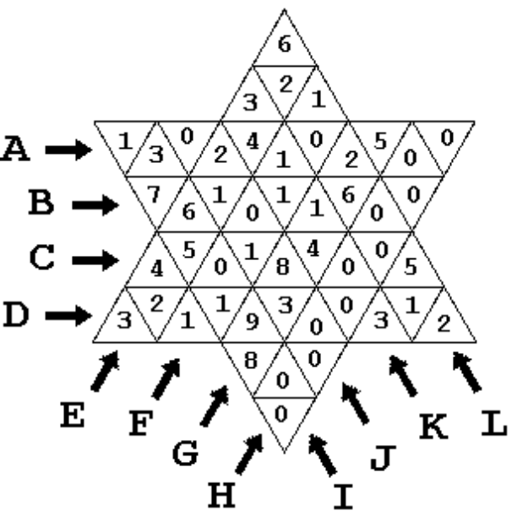
Figure 1
The board contains 48 triangular cells. In each cell one digit from 0 to 9 is written. Each cell belongs to two or three lines, which are marked by letters from A to L. One possible disposition of digits in cells is shown on figure 1. In this example the cell with 9 belongs to lines D, G and I, but cell with 7 - to B and I.
There is known the greatest digit, which is written in line cells for each line. In the given example the greatest digit in line A is 5, in line B - 7, in line E - 6, in line H - 0, in line J - 8, and so on.
Your goal is to write a program STAR which for given greatest digit in each of twelve lines determines the least and the greatest possible sum of digits in all board cells.

INPUT DATA
The first line of text file STAR.IN contains twelve digits - the greatest digit in line A, the greatest digit in line B, ..., the greatest digit in line L, respectively. Each two neighbour digits are separated by one space character. An example:
5 7 8 9 6 1 9 0 9 8 4 6

OUTPUT DATA
The output text file STAR.OUT must contain two integers in the first line: the least and the greatest possible sum of digits in all board cells. Values must be separated by single space character.
If it is not possible to dispose digits in cells to fulfil all given conditions, the text "NO SOLUTION" must be written in the first file line.
For the input example, the output file should be:
40 172

Baltic codes (EST, 1 min per test, 40 points)
In this task we consider texts consisting of letters a…z, A…Z and space. The symbols of the texts are represented by 16x16 matrices consisting of 0 and 1. Some symbols look like printed text, some can be handscript-like. Some of them are very bold and some are written with thin lines. The letters may reach the edges of the matrix but they also can be smaller (but the height of highest letters is at least 8 pixels).
We assume that our text documents are divided for sending from one computer to another in chunks of 25 symbols. Each such chunk is converted by the program BALTCO into a package of 25 text lines containing from 1 to 100 digits 0..9 and sent to another computer. The program BALTDECO converts the package back to 25 symbol matrices. It is desirable that the result differs from the initial picture by no more than 10 corrupted pixels in each symbol.

Task
Fix some way of coding the document chunks by 25 lines of the digits and write two programs: BALTCO for coding a text chunk, BALTDECO for decoding.
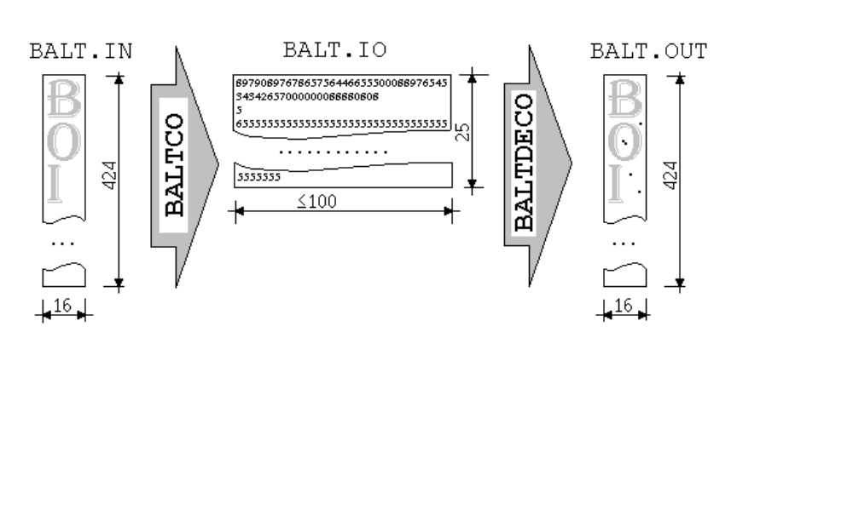

Input data of BALTCO
The input file BALTCO.IN contains 424 lines and consists of 25 symbol matrices separated by one blank line. Different words of the text can be written using different font. The file BALTCO.IN on your disk begins with symbol B:
1111111111111100
0111000000000110
0111000000000011
0111000000000011
0111000000000011
0111000000000011
0111000000000110
0111111111111100
0111000000000110
0111000000000011
0111000000000011
0111000000000011
0111000000000011
0111000000000011
0111000000000110
1111111111111100

Output data of BALTCO
Output file BALT.IO must contain 25 lines of length at least 1 and no more than 100 filled with decimal digits (without spaces).

Input data of BALTDECO
The lines of digits from file BALT.IO is used as input data of BALTDECO.

Output data of BALTDECO
BALTDECO must write in output file BALT.OUT the 25 symbols of initial text in the same format as BALT.IN. Each symbol matrix should differ from initial input by no more than 10 corrupted pixels.

Grading
There will be 8 tests for this task. The result for a test is computed by following formula:
(total number of digits in jury’s solution for this test) × 5
(total number of digits in your BALT.IO) × 2^{w}
where w is the number of symbols forwarded with more than 10 corrupted points. Maximal possible score for a test is 7 points (it is clear that some coding can be much more effective for some test). The maximal possible overall score for this problem is 40, however.

Additional
The program BALTTEST.EXE on your disk compares files BALT.IN and BALT.OUT and reports in BALTTEST.OUT about corrupted pixels in every symbol matrix (the number of matrices in the files can be less than 25).

